Impaired Glove for Blind and Impaired Person

Bushra Rahmani Najam us Sehar
bushrarahmani45@gmail.com najamussehar18@gmail.com

Rabiya Rafique Summan Taba
rabiyasheikh83@gmail.com summantaba@gmail.com
Ms. Ummay Faseeha
ummay.faseeha@gmail.com

Computer Science and Information Technology (Jinnah University for Women) Karachi, Pakistan

Abstract:

The challenges faced by blind people in their everyday lives are not well understood. The main problem is that they can’t go anywhere without any assistance. And so many problems they are facing, also the main problems they are facing in learning. So, proposed system is develop to resolve a bit problems to them. To cater this issue, embraces a subjective and subsequent quantitative request to comprehend the academic difficulties looked by blind and children in secondary school and universities, their determination techniques and the utilization of innovation to determine their issues. We try to develop a portable glove that support blind people. With the help of this glove blind can go anywhere without assistance. Navigation feature is also provided, in case of any obstacles detected by camera and notify through voice. Furthermore GPS tracking system is provided that track the person wherever they go. We also developed an application named as “Impaired Glove” that track the blind person.
Keywords:

Blind students, visually impaired, Academic challenges, Education.

INTRODUCTION:

There are about two million visually impaired or blind persons ^{[1]}. People with visual impairment fall more often than those with normal sight. They may fail to see or over correct in stepping over environmental hazards and may have difficulty taking corrective action after a stumble.
They can’t go anywhere without second person. So, for these problems they are facing in every day’s life we have decided to make glove for blind’s people where they can use anywhere like if blind wants to go they can use glove and that glove has the ability to navigate the path, distance and tells the blind if there is any hurdle or obstacles or barrier by sound frequency, or if blind wants to know the object so he can use “Impaired Glove Application” that detect the object and tells the object by voice recognition. For students they can use gloves for studies or to detect the shapes, textures by glove. Shape recognition mode is utilized to learn about the edges of the item and the surface mode enables the client to feel varieties in the surface of a picture. Blind person can’t type the message so here blind can type the messages by taping their fingers by glove using impaired glove application.
This article focuses on blind and impaired person that face these types of problems in every day’s routine.

Background:

Ultrasonic sensor, Arduino, IR sensors. Where ultrasonic sensor measure the distance and sends out a high frequency pulse when there is any barrier/ obstacles. The sensor has 2 start on its obverse. One initial transmits ultrasonic waves, (comparable to a little speaker), alternate receive them, (similar to a small amp) [2].We use IR sensors in our glove that sense and detect the shapes. It is utilized to get a handle on the edges of the item An IR sensor can detect the daintiness or dimness of a surface with material criticism from a vibration engine. We use Arduino to embed our coding of the hardware like IR sensor, ultrasonic sensor [3]. Arduino is a single board microcontroller intended to make the application more accessible which are interactive items and its environment. The hardware highlights with an open-source hardware board outlined that enables the user/client to append different extension boards. Keeping in mind the end goal to begin, they are essentially associated with a PC and USB cable or with an AC-to-DC connector or battery [4].

Related Work:

Work related for blind people are (i) Applying QR code and portable phones for blinds

(ii) Usable gestures for blind people, (iii) A combined inside/outside for impaired people navigation system, (iv) Tactile display for the optically impaired using Tesla Touch.

Applying QR code and portable phones for blinds:

Applying QR code and portable phones for blinds, worked on a barcode based framework to help the blind and impaired person to recognize objects in nature is introduced. The framework depends on using QR codes (two-dimensional barcode) appended to a protest and examined utilizing a camera telephone outfitted with QR reader software. The software decodes the barcode to a URL and mentor the mobile's program to get a sound record from the Web that holds an oral description of the object. Our proposed outline is required to be helpful progressively communication with several situations.

Usable gestures for blind:

Regardless of developing awareness of the accessibility issues surrounding touch screen use by impaired people, planners still face challenges while making open touch screen interfaces. One noteworthy stumbling block is a lack of understanding about how blind people really utilize touch screens. We led two client contemplates that looked at how blind and sighted people utilize touch screen motions. To start with, we directed a signal elicitation think about in which 10 visually impaired and 10 located individuals imagined motions to perform basic processing assignments on a tablet PC. We found that visually impaired individuals have different gesture preferences than located individuals, including inclinations for edge-based gestures and motions that include tapping virtual keys on a keyboard.

An Integrated Indoor/Outdoor System:

There are many navigation system for blind yet rare can give dynamic associations and versatility to changes. Nobody of these frameworks work flawlessly both inside and outside. Drishti utilizes an exact position estimation framework, a remote association, a portable PC, and a verbal statement line to manage impaired clients and support them to movement in common place and new conditions freely and securely.

- Tactile display for Blind:

Tesla Touch is an innovation that gives material sensation to moving fingers on touch screens. In view of Tesla Touch, we have created applications for the visually impaired to interpret and make 2D tactile information. In this paper, we exhibit these applications, show perceptions from the association, and examine Tesla Touch's potential in supporting correspondence among outwardly impaired people.

Proposed Description:

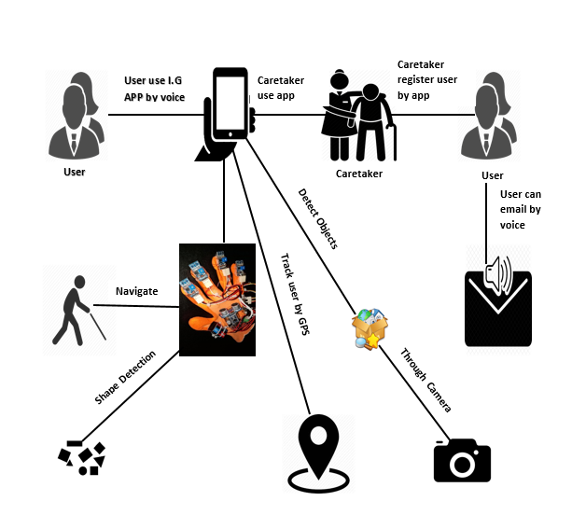
Fig1. Proposed diagram of impaired glove

The above proposed diagram show the flow of our project. A portable Glove which support blind people. The glove will help the blind people to navigate their right path. During navigation if any obstacles/barrier will find in front of them they can detect it with the help of ultrasonic sensor which we use in the glove and user will come to know by the frequency of sound. Camera detect the object and convey message to blind person through voice recognition by an “Impaired Glove” application. With this glove it can recognize the different shapes, alphabets and textures of an image. They can also gain their typing ability by taping their fingers in typing mode. In typing mode we embed the IR sensor and vibrating motor on the finger tip of glove.IR sensor detect the black texture on white paper and vibrating motor vibrate only if we place our finger on black texture.so user can easily detect the shapes, textures through vibration .In Impaired glove application there are two modes caretaker and user mode. In caretaker where caretaker register his/her self and track the blind people. Caretaker may register multiple users. Caretaker will responsible to track the user’s location through GPS tracking system. If user go anywhere caretaker detect the user’s position and get notify by the application.

Modules:

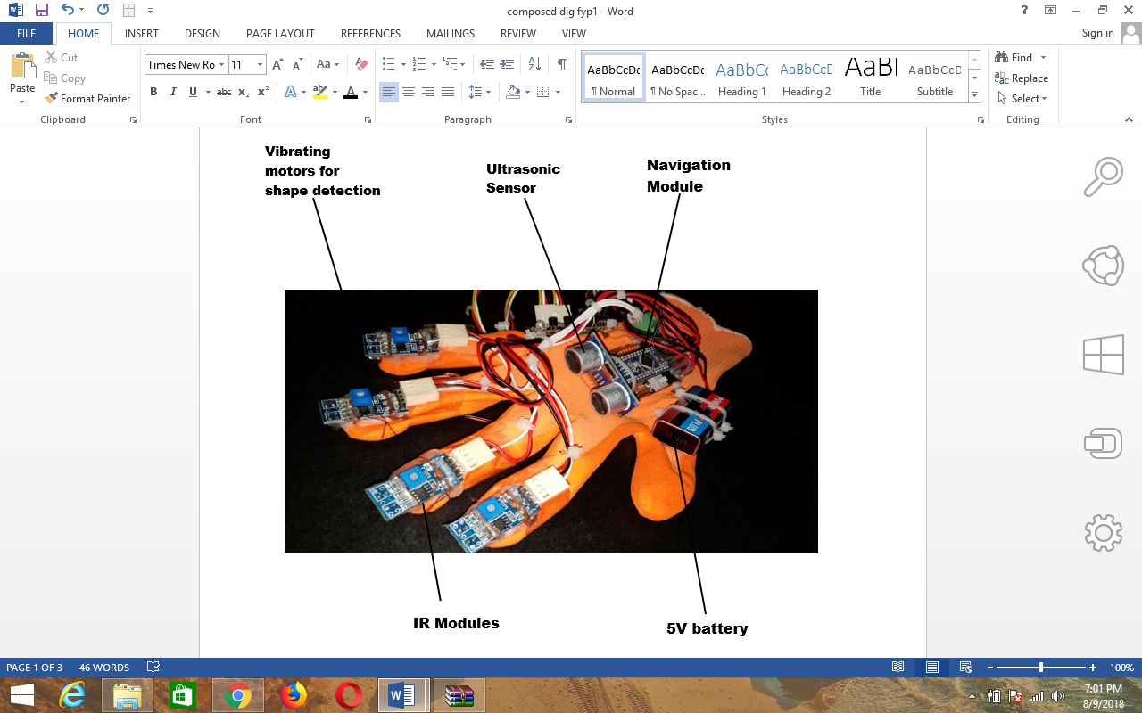

Shape detection:
This is most important module for the students who are impaired or blind and face lots of problems during studies. In this blind can understand the edges of the item like detect the shapes using this module.

Texture:
This mode enables the client to feel varieties in the surface of an item.

Navigation:

This is the main module where blind or impaired person can easily navigate their right path. As they face lots of problems if hurdles or any other obstacles in front of them so that this mode give the feedback in beep sound.

Typing:
In typing mode user / blind/ impaired person can typing their fingers by tapping using this mode easily we just approach four sensors on our gadget that can be utilized for this reason, which limits us to 16 characters and when they tapping their fingers on flat surface alphabets tap on the smartphone using impaired glove’s application.
GPS Tracking:
In this module, Caretaker will responsible to track the user’s location through GPS tracking system. If user go anywhere caretaker detect the user’s position and get notify by the application and can track them easily.

Conclusion:

Our project aim is to support blind people who are facing so many problem with their disabilities. So, we developed portable glove which we focused to enhance their learning abilities through shape detection and textures recognition. We provide a mini camera on the glove for blind to understand what object in front of them so this they can easily detect the objects.
We provide typing ability to blind which they can’t do it before. Furthermore, caretaker does not know where the blind person is? So here we provide GPS tracking system facility through impaired application to caretaker where he can track blind person easily. So, despite all the things we develop a portable glove that fulfill their basic needs.

References:
1. Resnikoff, Serge, et al. "Global data on visual impairment in the year 2002." Bulletin of the world health organization 82.11 (2004): 844-851.
2.Carullo, Alessio, and Marco Parvis. "An ultrasonic sensor for distance measurement in automotive applications." IEEE Sensors journal 1.2 (2001): 143-147.
3. Morimoto, Carlos Hitoshi, et al. "Pupil detection and tracking using multiple light sources." Image and vision computing 18.4 (2000): 331-335.
4. Ulrich, Iwan, and Johann Borenstein. "The GuideCane-applying mobile robot technologies to assist the visually impaired." IEEE Transactions on Systems, Man, and Cybernetics-Part A: Systems and Humans 31.2 (2001): 131-136.
5.Badamasi, Yusuf Abdullahi. "The working principle of an Arduino." Electronics, computer and computation (icecco), 2014 11th international conference on. IEEE, 2014.
6. Campbell, A. John, et al. "Randomised controlled trial of prevention of falls in people aged≥ 75 with severe visual impairment: the VIP trial." Bmj 331.7520 (2005): 817.
7. Al-Khalifa, H. S. (2008, July). Utilizing QR code and mobile phones for blinds and visually impaired people. In International Conference on Computers for Handicapped Persons (pp. 1065-1069). Springer, Berlin, Heidelberg.
8. Ran, L., Helal, S., & Moore, S. (2004, March). Drishti: an integrated indoor/outdoor blind navigation system and service. In Pervasive Computing and Communications, 2004. PerCom 2004. Proceedings of the Second IEEE Annual Conference on(pp. 23-30). IEEE.
9. Kane, S. K., Wobbrock, J. O., & Ladner, R. E. (2011, May). Usable gestures for blind people: understanding preference and performance. In Proceedings of the SIGCHI Conference on Human Factors in Computing Systems (pp. 413-422). ACM.
10. Xu, C., Israr, A., Poupyrev, I., Bau, O., & Harrison, C. (2011, May). Tactile display for the visually impaired using TeslaTouch. In CHI'11 Extended Abstracts on Human Factors in Computing Systems (pp. 317-322). ACM.

